Contents

**What is Unit Testing?** 1

**Unit Testing vs Other Types** 1

**Test Driven Development** 2

**JUnit** 3

**FIRST Principles of Testing** 3

**Sean’s Unit Testing Rules of Thumb** 3

*'It costs almost five times more to fix a coding defect once the system is released that it does to fix it in unit testing.'*

*– PAUL GROSSMAN, IT CONSULTANT*

[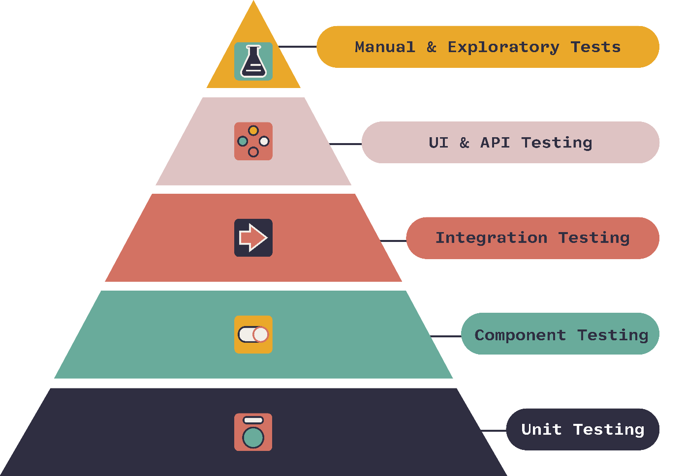](https://www.onpathtesting.com/blog/qa-testers-what-is-the-agile-testing-pyramid)

## **What is Unit Testing?**

- Unit testing is the process of writing code to _______________________________

- We should strive to break the function to ensure that it meets quality criteria

- We should also strive for _____ code coverage

- Every single line of code in our application should be run through our unit tests

- We should also write code with the intention of it being tested (thinking in terms of ________)

- Edge cases being ___________________________________________________

- Ex: ___________________________________

## **Unit Testing vs Other Types**

[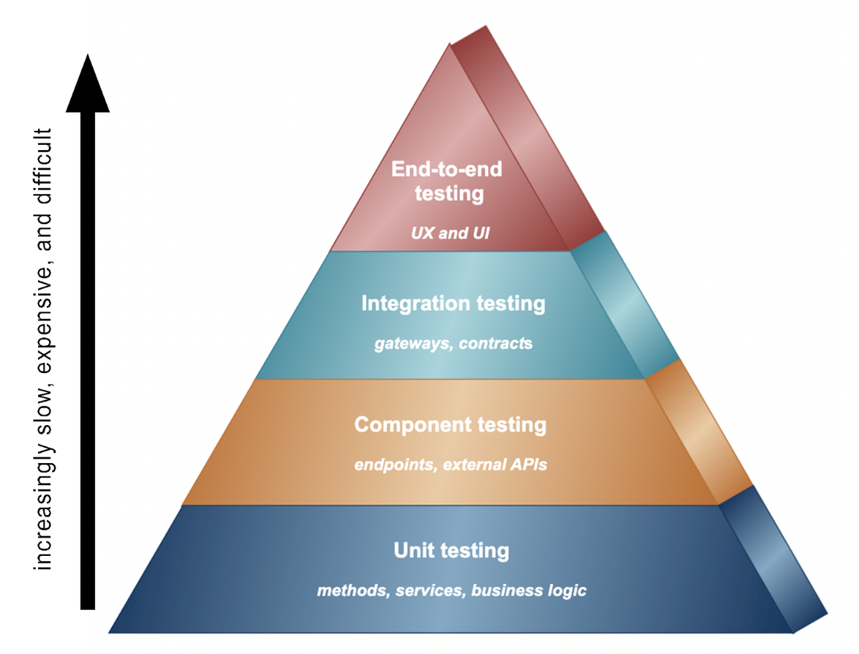](https://www.cortex.io/content/an-overview-of-the-key-microservices-testing-strategies-types-of-tests-and-the-best-testing-tools)

**Unit Tests** - Tests ______________

**Component Tests** – Tests ________________

**Integration Tests** - Tests _________________

**UI Tests**- Tests _________________________________

**Manual Tests** – Tests ________________________

**Regression** **Tests** – Tests ________________________________

**Stress** - Tests _____________________________________

**Others**: functional, black-box, End-to-End, Fuzz, Penetration, Security, etc.

## **Test Driven Development**

- Test Drive Development (TDD) is _____________________________________________

- ______________ before ________________

- Yes, the tests will initially _____________________________

- This makes you think through ______________________ before ___________________

- TDD was first developed by _______________________

- for history of TDD read <https://semaphoreci.com/blog/test-driven-development>

- _____________ is one of several ___________________

- We will cover the [Agile Development Manifesto](http://agilemanifesto.org/) more in depth in a later week

1. ___________________ over processes and tools

2. ___________________ over comprehensive documentation

3. ___________________ over contract negotiation

4. ___________________ over following a plan

- It's widely used out in industry because it encourages developers to write good unit tests

## **JUnit**

- JUnit is ____________________________________

- It is the most popular ______________ in Java

- It supports ­­­­­­­­­­­___________ and _________ for testing

- I can write specific methods to ____________________________________________

- This same principle applies for ___________________________________

## **FIRST Principles of Testing**

* Fast
* Isolated/Independent
* Repeatable
* Self-validating
* thorough

- Fast = ­­­­­­­­­­­­­________________________

- Isolated/Independent = _____________________

- follow the 3 A’s

1. Assemble = ______________________________

2. Act = ______________________________

3. Assert = _______________________

- Repeatable = _____________________

- Thorough = ______________________

- To read more about the FIRST principle read this [article](https://medium.com/@tasdikrahman/f-i-r-s-t-principles-of-testing-1a497acda8d6)

## **Sean’s Unit Testing Rules of Thumb**

- If a method throws an exception, you should ensure that it DOES throw the exception

- Additionally, the exception should NOT be thrown in valid cases

- Run tests for null values

- When testing numbers, use the rule of "one, none, or some"

- Test that it works with a singular value (works because odd numbers are harder to work with (typically))

- Also, 1 is a prime number

- It's also good to test an even number

-- This ensures that it works for both odd and even

- Test with no values

-- This will handle empty arrays/null values/etc.

- Test with some values

-- Typically, I create a large mock data file (csv) and use the mock data to simulate the actual thing

- Test with negative numbers

-- Often these will go unnoticed in development

-- Handles overflow that way (integer overflow)

- Ask yourself what logical edge cases there are

-- Things like ties, negative numbers, invalid format, business requirements, etc.